iMITS Release Notes

**Deployed Date:** 25/01/2018

**Features**

1. **Feature**: MGI CRISPR Allele Report

**Description**: This report will be used to register IMPC alleles with MGI. MGI will use this report to generate new alleles and allocate MGI accession ids. This report generates automatic allele description base from the F1 colonies allele_types and allele_subtypes supplied through the mi_attempts F1 colony section. These allele descriptions will become more descriptive when we have written a mutation analysis pipeline to process the Fasta files uploaded by the centers. MGI will update the allele descriptions as they change when more data becomes available which will allow us to register IMPC allele prior to receiving all the data from the centers, however allele_type and allele_subtype will be the minimum requirement.

**iMITS data changes:** All CRISPR alleles have now had the (IMPC) tag added to them eg. em1(IMPC)J

**Navigation:** <https://www.i-dcc.org/imits/v2/reports/v2/reports/mgi_crispr_allele_report.tsv>

1. **Feature**: Plan conflict update

**Description**: It was recently pointed out that some centers (in the early days) carried out only ES Cell QC and iMITS had marked those lines as reserved for those centers and would assign conflicts when another center showed interest.

Functionality has now been added which allows centers to indicate that the plan created is solely for carrying out ES Cell QC. This is similar to the phenotype_only flag. It is a tick box that you can use when you create a plan through the ‘Gene Selection’ page. These two flags both indicate that no mouse production will take place and therefore plans with either of these flags will not result in a conflict when another center register interest in the gene. These plans will also not appear in the assigned column on the ‘Gene Selection’ page and the ‘Gene List’ report.

**iMITS data changes:**

* All plans with no Micro injection, which have the status related to ES CELL QC have been marked as es_cell_only.
* All plans with no Micro injection, which have the status ‘ES CELL QC in progress’ have been set to ‘Aborted - ES CELL QC Failed’.

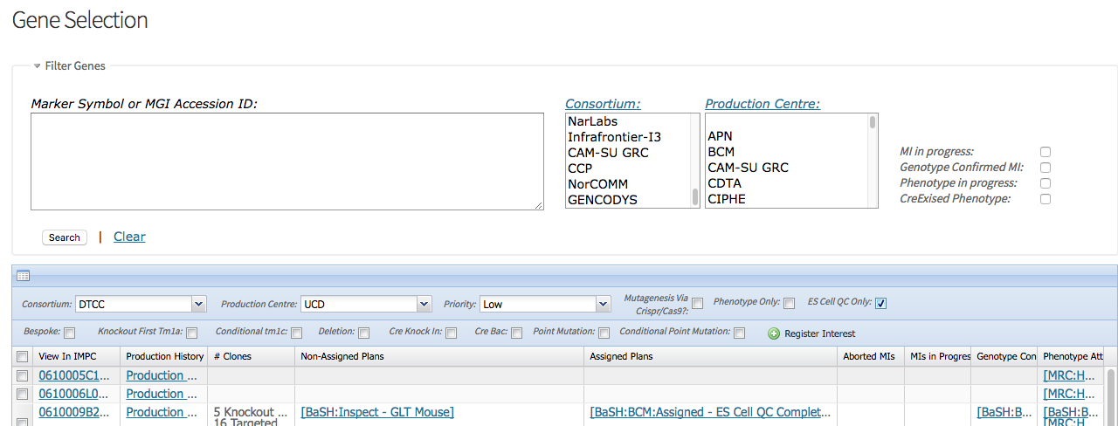

New ES Cell QC Only Flag

**What is new:**

* ES Cell QC only has been added to the ‘Gene Selection’ page. If you want to enter a ES Cell QC only plan set the ES Cell QC only flag to true when registering interest.

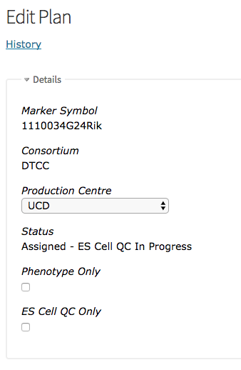

* The ES Cell QC only flag has also been added to the ‘Plans’ edit page. You can set existing plans to be ES Cell QC only plans here (We have already done this for you for most existing plans).
* Gene Selection grid has been reorganized.
  + Phenotype_only plans now appear in the ‘Phenotype Attempts’ column. Obviously if no phenotype attempts have been created for one of these plans then the phenotype attempt count will be zero (the integer to the right of the production center’s name).
  + Only assigned plans will appear in the ‘Assigned Plans’ column. This covers all plans that either have Micro injections or where the plan is the first for that gene.
  + 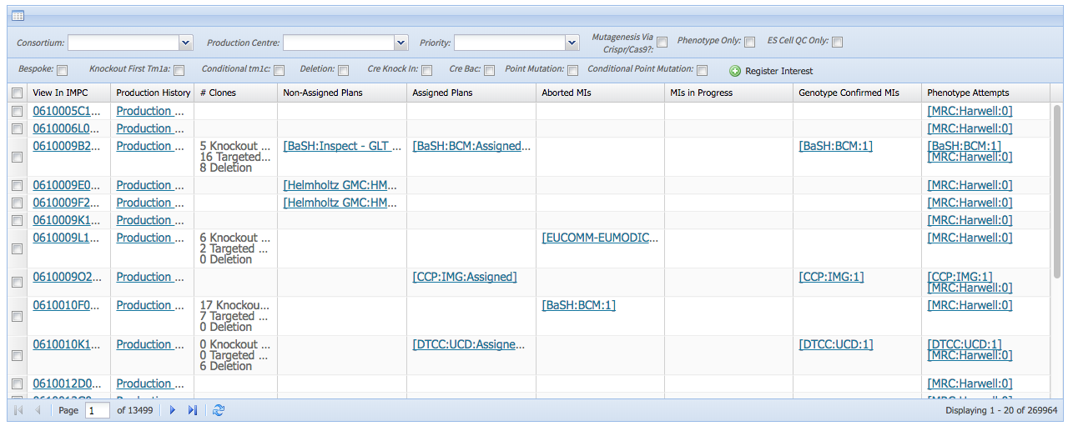Aborted Plans are not displayed
  + All conflict plans or ES Cell QC only plan appear in the ‘Non assigned plans’ column. These plan show which centers are interested in targeting the gene in question. If no plan shows in the ‘Assigned Plans’ column these centers should be consulted before assigning the gene to your production pipelines (‘ES Cell QC only and withdrawn plans can be ignored’).
  + These grouping have been replicated in the ‘Gene List’ report (<https://www.mousephenotype.org/imits/reports/genes_list.csv>).

**Fixed Bugs**

* Creating Mi Attempts has slowly been getting slower resulting in a proxy timeout.

FIXED Users should see a notable reduction in waiting times when creating new Mi Attempts.

* Reports ‘All Genes’ and ‘Double Production between consortia’ resulted in an error.

FIXED These reports can now be run.

**System Infrastructure maintenance**

* Upgraded ruby version to 2.2.9
* Upgraded ruby GEMS to remove security vulnerabilities

UPGRADED Small improvements noticed in applications responsiveness.